Adding LVT Site using Al Link
Old Set up, we no longer use this set up but incase we do. We have documentation
Once added into Immix, the site will be added into Actuate on its own once an alarm is triggered. We will just need to ensure the site is enabled and the schedule is not in place so we can receive alarms. Once testing has been completed, place schedule back in place. If testing overnight, ensure schedule is in place. Below will be the step-by-step process on how to add Alarms into Immix. This will be the same process with Hikvision & Axis Devices.

Please keep in mind for all LVT sites, we will need to add the necessary information in the description according to the Service Level Package (This will be located on the CIF, Majority of the sites should have Standard). On the LVT Tech Files on Teams, you will locate the document ‘LVT Standard Protocols’ Sheet. This will provide the description we will need to place.

How to Add Alarms on Immix:
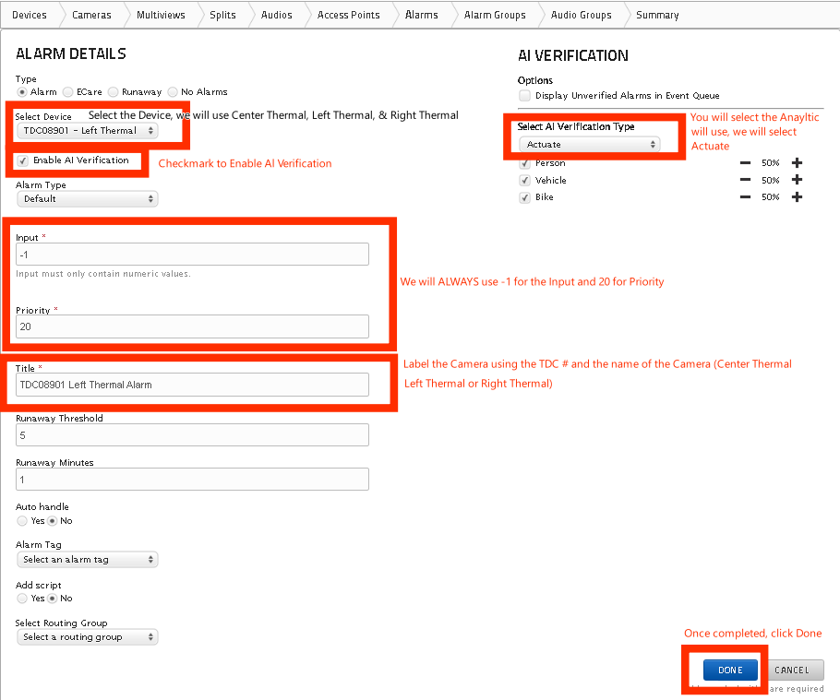
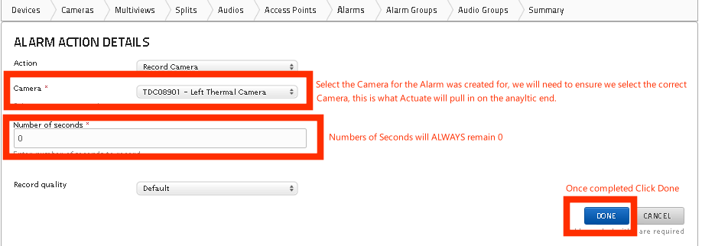
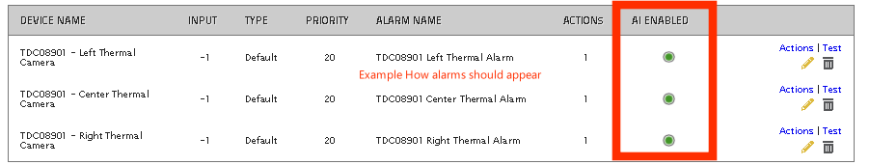
PTZ:
All LVT Cameras will need to have PTZ capability except for Fisheye Cameras. For Axis Cameras, ensure Telemetry is checked. For Hikvision, we will need ONVIF profile created and ONVIF to be enabled.
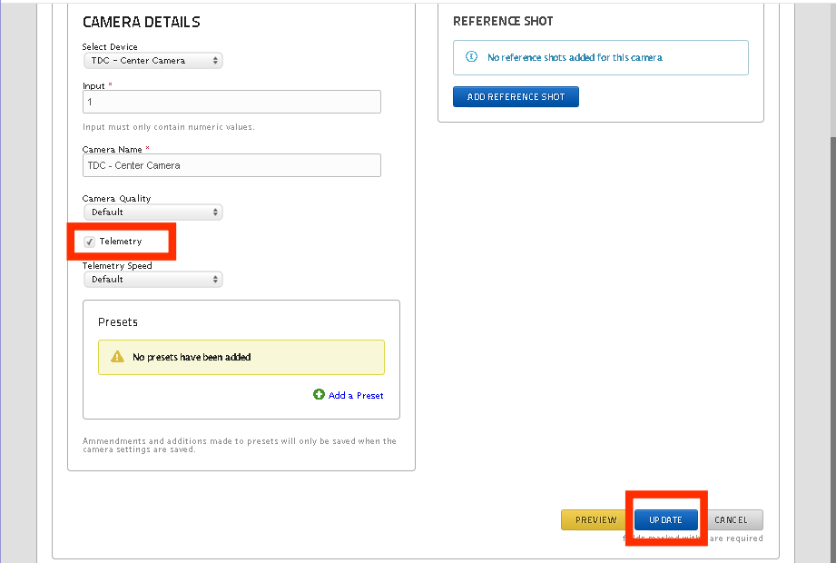

How to add Into Hikvision:
You will need to gather the Device S# on Immix for Each Thermal Camera an alarm was created for. Each camera will have a unique email address (SMTP Server Address).
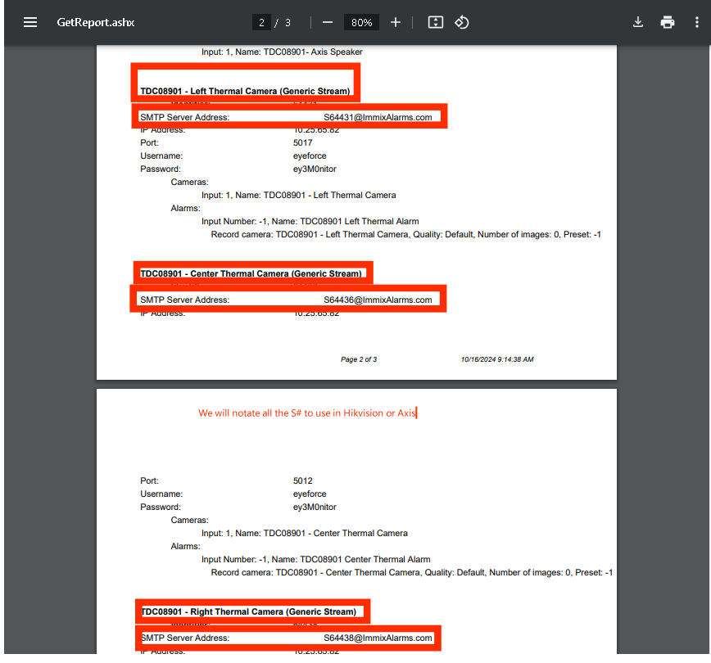
Once all S# are gathered, we will need to access Mremote to be able to access the Cameras on Hikvision. Once you have access to each camera, we will take the steps below:
- Click on Configuration
- Click on Network
- Click on Advanced Settings
- Click Email
  - In this section is where we will add the SMTP Email Address per device from Immix, Immix SMTP email (dev.eyeforce.online)
  - Sender: Eyeforce
  - Sender’s Address: SMTP Email Address per device (Center, Left, & Right Camera)
    - Ensure you are using the correct SMTP email for the correct camera
  - SMTP Server: dev.eyeforce.online
  - SMTP Port: 25
  - Attached Images: 2
  - Receiver: Immix
  - Receiver’s Address: Use the same email used on Sender’s Address
  - Test – You should receive a successful test
- Save Information
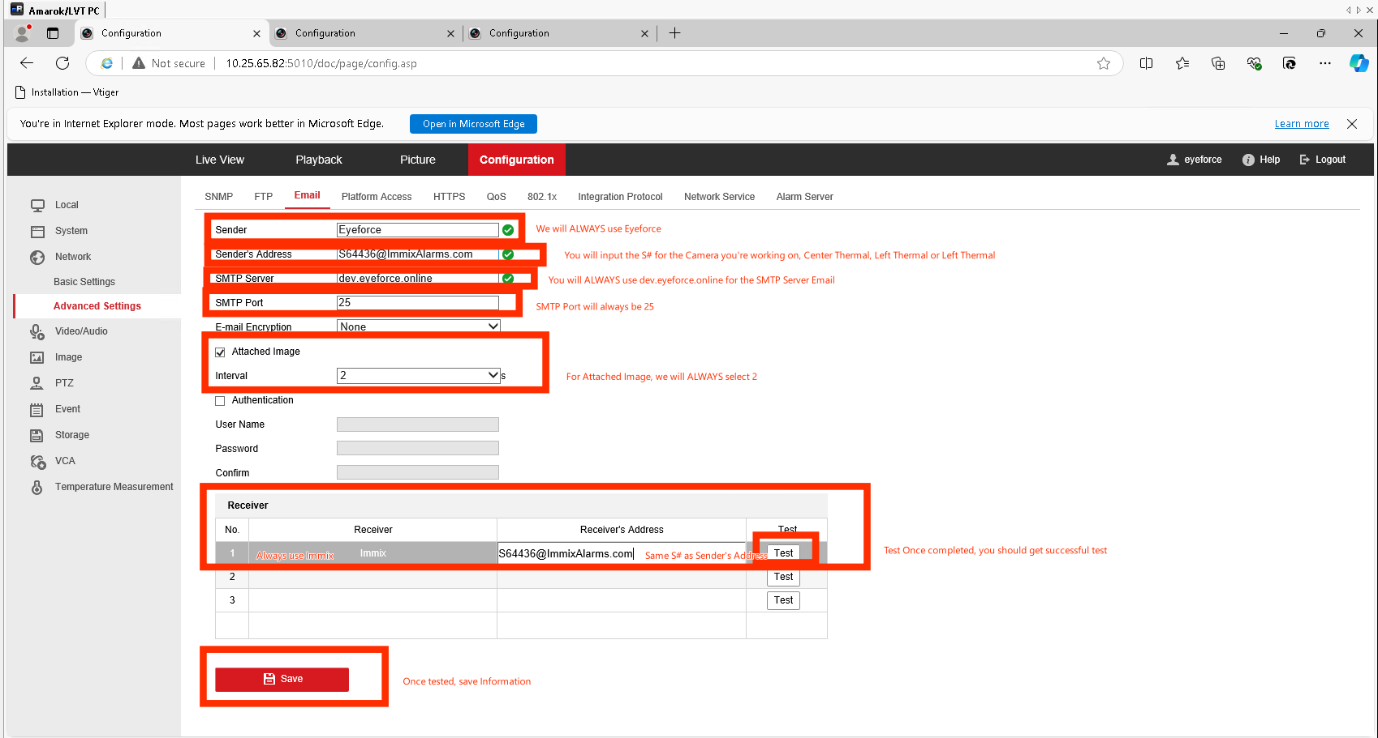
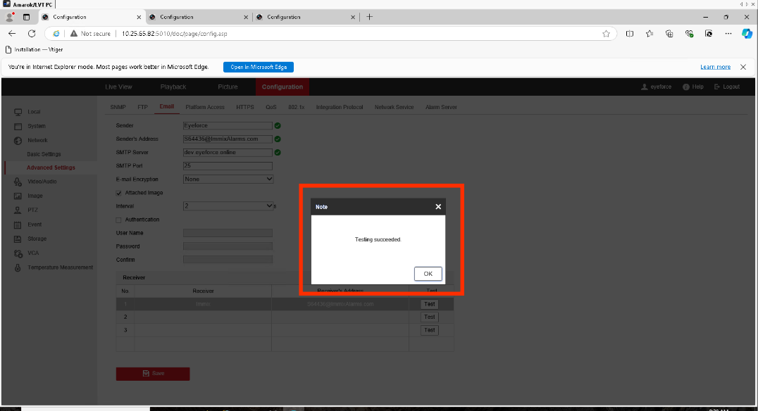
Now we must ensure the rules are set up and Send Email is checked on VCA, click on VCA then Scene Configuration (Scene 1). Ensure the rules are set up. Once confirmed, click on Alarm Linkage and checkmark send email for the Rules on the list.
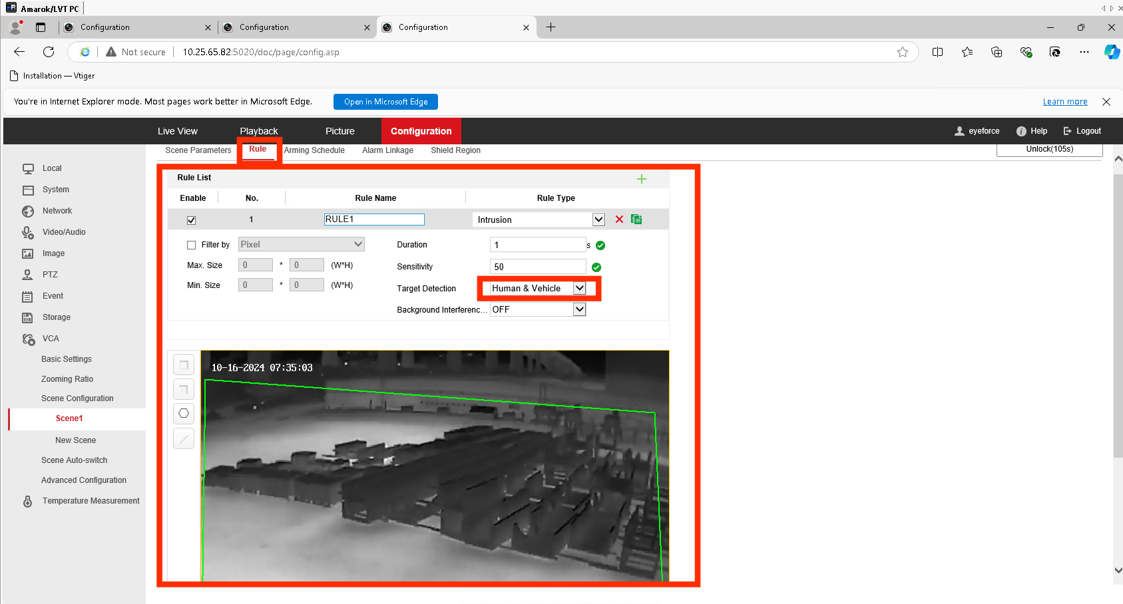
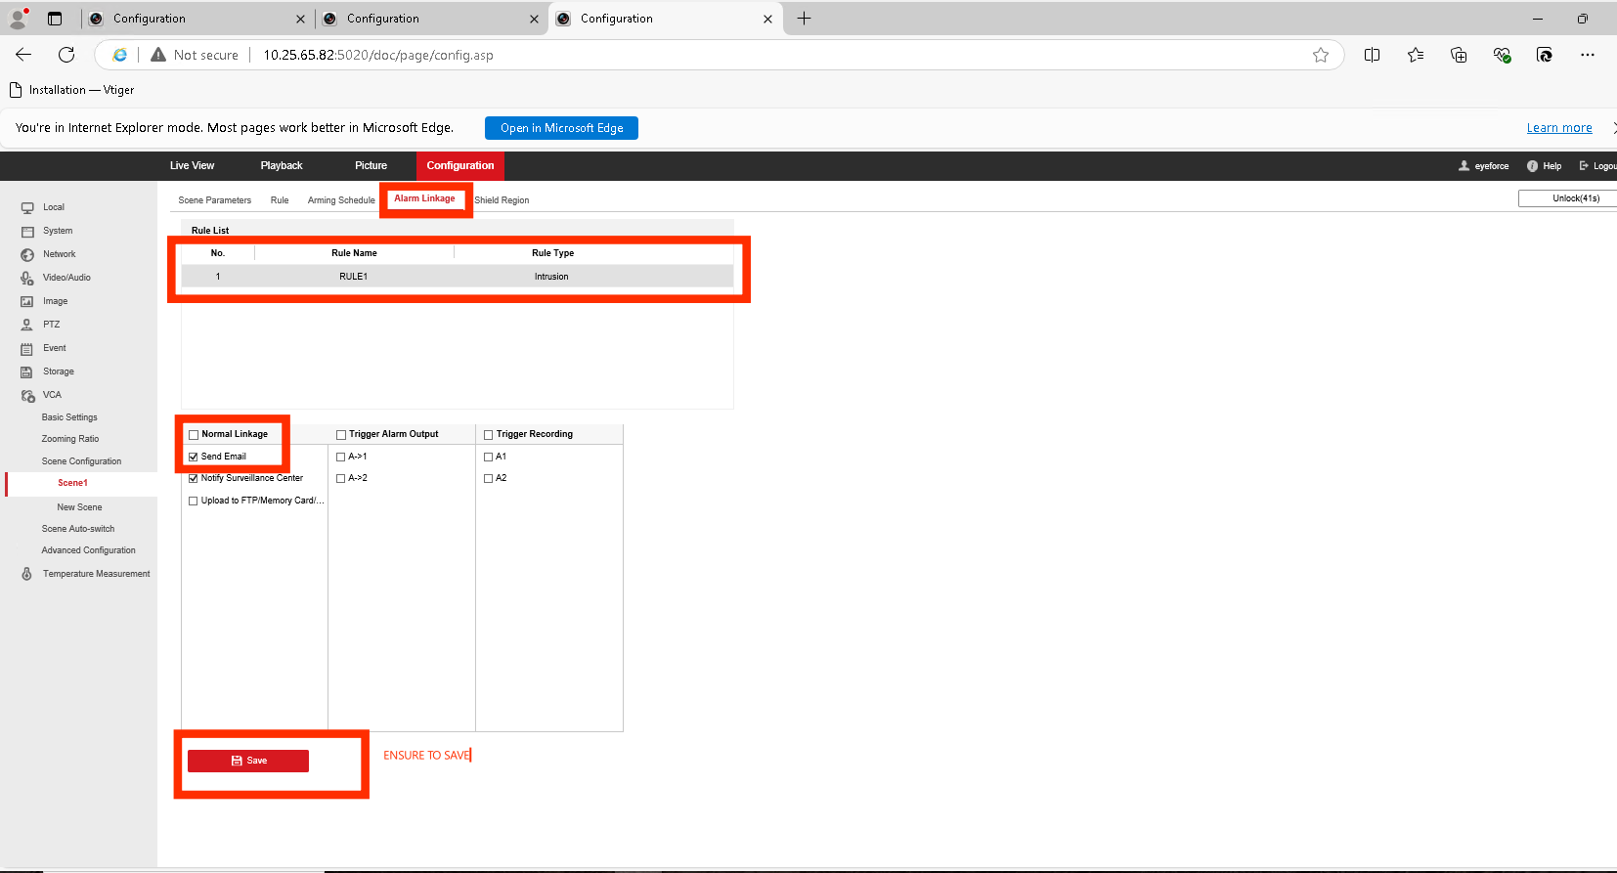

How to Add into AXIS:
You will need to gather the Device S# on Immix for Each Camera an alarm was created for. Each camera will have a unique email address (SMTP Server Address).
Once all S# are gathered, we will need to access Mremote to be able to access the Cameras on Hikvision. Once you have access to each camera, we will take the steps below:
First you will click on Apps and ensure Axis Object Analytics is enabled or Loitering Guard (Depending on the site set up). Once confirmed app is enabled, we will then take the steps below:
- Click on Systems
- Click on Events
- Click Recipients
  - Click Add Recipient
  - Name Immix – Eyeforce
  - Type – Email
  - Send email to: SMTP Server Address for each camera
    - Ensure the correct email address is being used for the correct camera
  - Send Email From: Same email used for Send Email to
  - Email Server (SMTP) dev.eyeforce.online
  - Port: 25
Imix
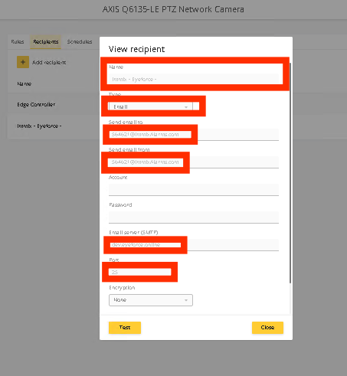
To add a Rule, you will stay in Events. Click on Rules then add Rule.
- Name: Eyeforce HD / VH
  - If both rules are set up then we will make a rule for each, if only one rule is set up then we will just make 1 rule. All depends on how many rules are set up.
- Condition: Select the rule that you’re set up
- Action: Send Images to Email – WE WILL ALWAYS SET UP USING SEND IMAGES TO EMAIL. If unable to do so, please review page 8 for further instructions.
- Recipient: Immix – Eyeforce (Recipient you set up)
- Send up to this many images per email: 10
- Prebuffer: 1 Second
- Post buffer: 1 second
- Maximum Images: 10
- Test – Should receive Successful Test then Save the Rule
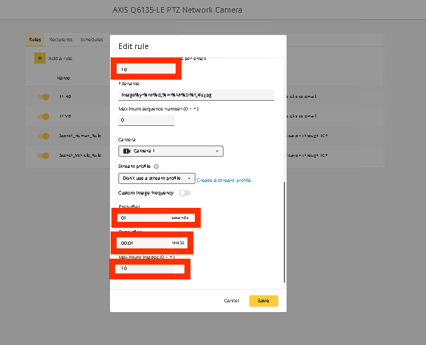

ADDING A STREAM IN AXIS – WE WILL ONLY USE THIS IF IT DOESN’T ALLOW US TO USE SEND IMAGES TO EMIAL on RULES, If unable we will create the stream and create the rules using Send Video to Email:

NEW PROFILE Needs to be created on Axis:

- Stream
  - Stream Profiles
  - Name the profile Eyeforce and keep at H.264
  - General
    - Resolutions: 1280x720
    - Frame Rate: 8
    - Compression: 0
- Encoding:
  - GOP Select
    - Set to 30
  - Select Bitrate Control
    - Set to 512
- SAVE

