LVT – Axis Setup

Take the IP provided by the CSM and change the .23 to .25, our servers will connect using the .25 octet.
Ex - 10.23.35.0 -> 10.25.35.0
They should use the same ports for all brands, listed below.
HTTP
Speaker – 3010
Center – 5010
Left – 5015
Right - 5020

We’ll get the Live view utilizing the HTTP ports, there are only color views and no thermal views here.
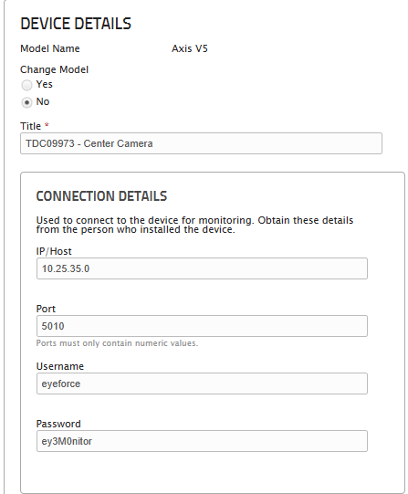
User: eyeforce
Pass: ey3M0nitor

Set up the alarms for the cameras in Immix and then create the site in Actuate.
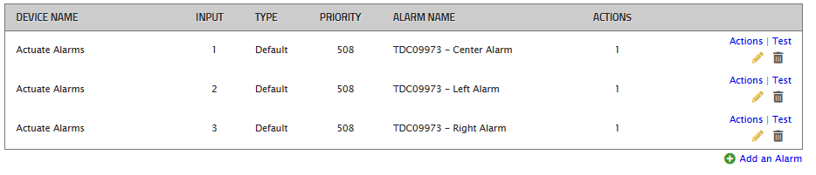
Input the SMPT info per device in the Recipients tab.
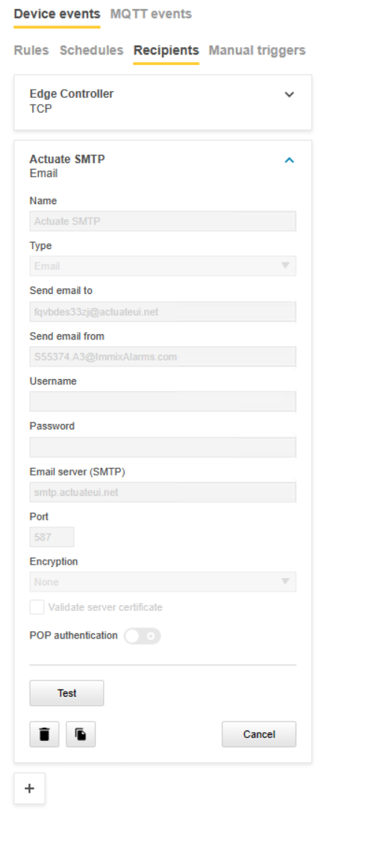

Verify the Object Analytics Configuration settings for both Human and Vehicle rules in each unit. 1s 1s
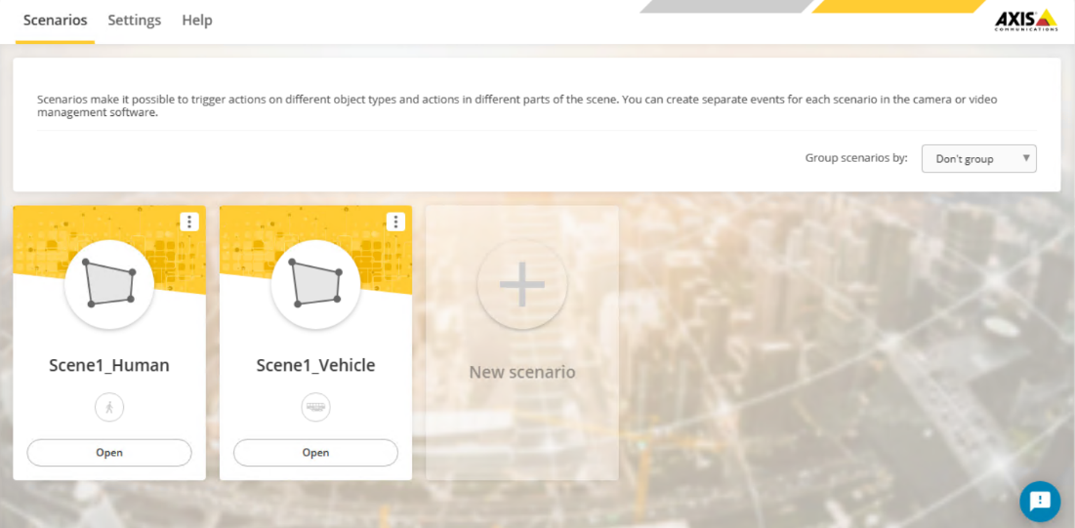

Configure the Rules for both Human and Vehicle detection to send to the Actuate Recipient.
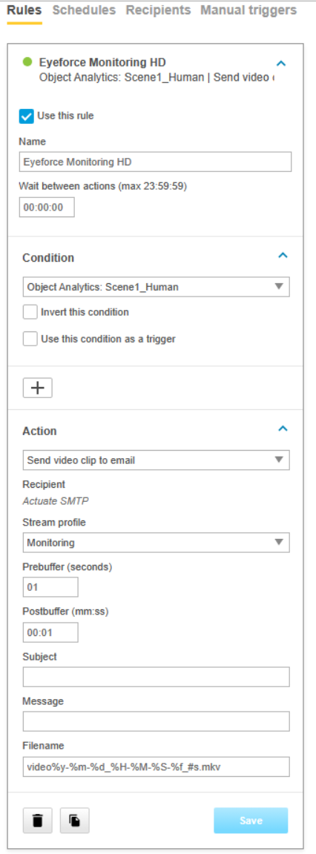

Repeat this for each device that is to be monitored then confirm receipt of the alarms in Actuate.
NEW PROFILE Needs to be created on Axis:

- Stream
  - Stream Profiles
  - Name the profile and keep at H.264
  - General
    - Resolutions: 1280x720
    - Frame Rate: 8
    - Compression: 0
- Encoding:
  - GOP Select
    - Set to 30
  - Select Bitrate Control
    - Set to 512
- SAVE

HOW TO ADD ON ACTUATE:

- Add Site – SMTP
  - Name the site
  - Select Intruder +
  - Next

- Add Camera information
  - Name of Camera
  - Camera View – Select if it’s a fish eye, Normal or Thermal
  - Immix Email – Actuate Email from the Generic Stream
  - HTTP – 5010, 5015, 5020
  - Host – IP Address
  - User/Password
  - Do the same for all cameras
  - Next
- Immix Server
  - Added Immix server – dev.eyeforce.online
  - Immix Port 25
  - Immix Email – Actuate Email
  - Immix input – This can stay blank once we get to the camera views, we can adjust accordingly

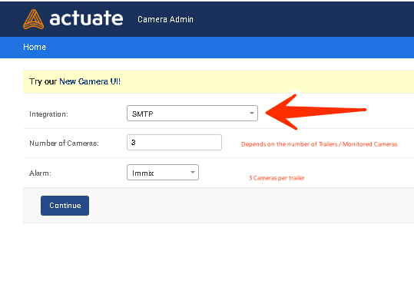
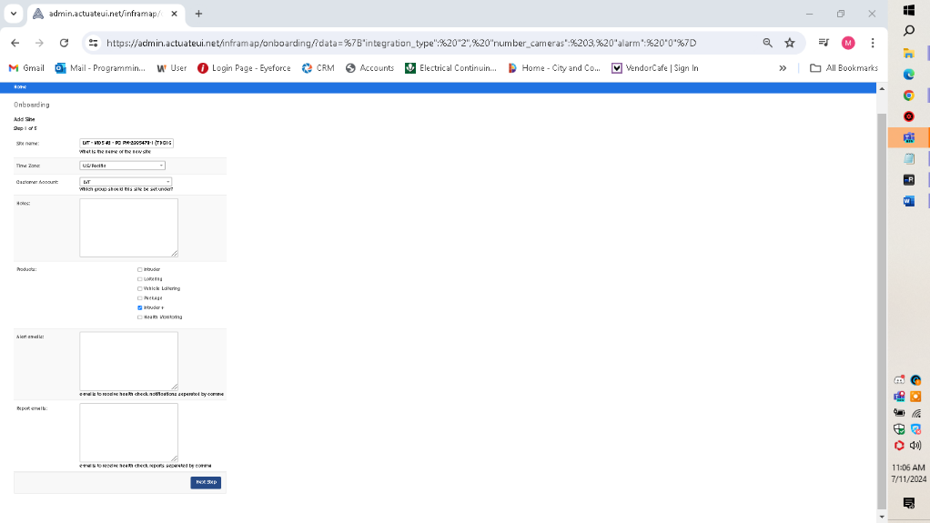

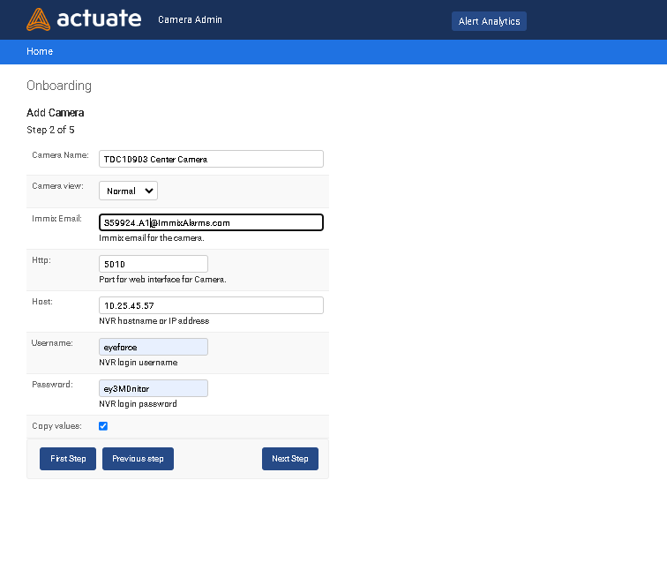

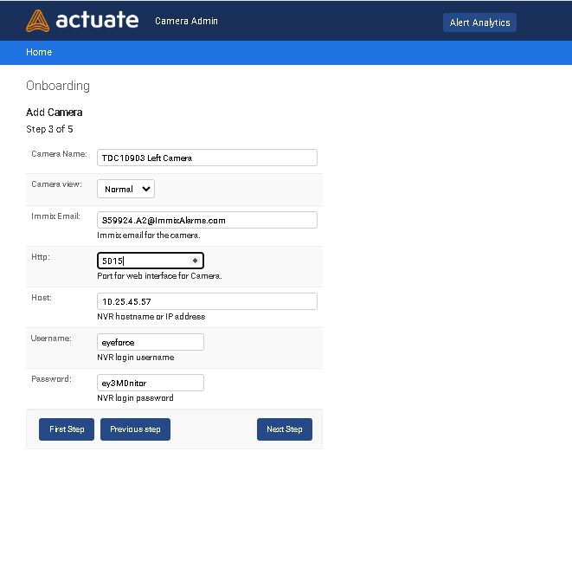

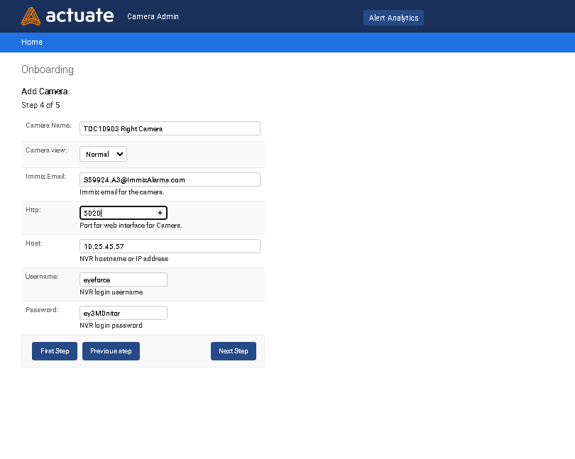

LVT – Hikvision Setup

Take the IP provided by the CSM and change the .23 to .25, our servers will connect using the .25 octet.
Ex - 10.23.34.126 -> 10.25.34.126

They should use the same ports for all brands, listed below.

HTTP
Speaker – 3010
Center – 5010
Left – 5015
Right - 5020

RTSP
Center – 5012
Left – 5017
Right - 5022

Control
Center – 5013
Left – 5018
Right – 5023

We’ll get the Live view utilizing the RTSP ports with the Hik RTSP URL below.
rtsp://eyeforce:ey3M0nitor@IP:PORT/streaming/channels/x02

Set up the alarms for the Thermal cameras in Immix and then create the site in Actuate.

Input the SMPT info per device in the Network Advanced Settings.

Verify the VCA Scene Configuration settings for both Human and Vehicle rules in each unit.

Then make sure to check the Send Email option in the Alarm Linkage section. Repeat this for each device that is to be monitored then confirm receipt of the alarms in Actuate.

HOW TO ADD ON ACTUATE:

- Add Site – SMTP
  - Name the site
  - Select Intruder +
  - Next
- Add Camera information
  - Name of Camera
  - Camera View – Select if it’s a fish eye, Normal or Thermal
  - Immix Email – Actuate Email from the Generic Stream
  - HTTP – 5010, 5015, 5020
  - Host – IP Address
  - User/Password
  - Do the same for all cameras
  - Next
- Immix Server
  - Added Immix server – dev.eyeforce.online
  - Immix Port 25
  - Immix Email – Actuate Email
  - Immix input – This can stay blank once we get to the camera views, we can adjust accordingly

